Things You Might Not Know on Hydroponics

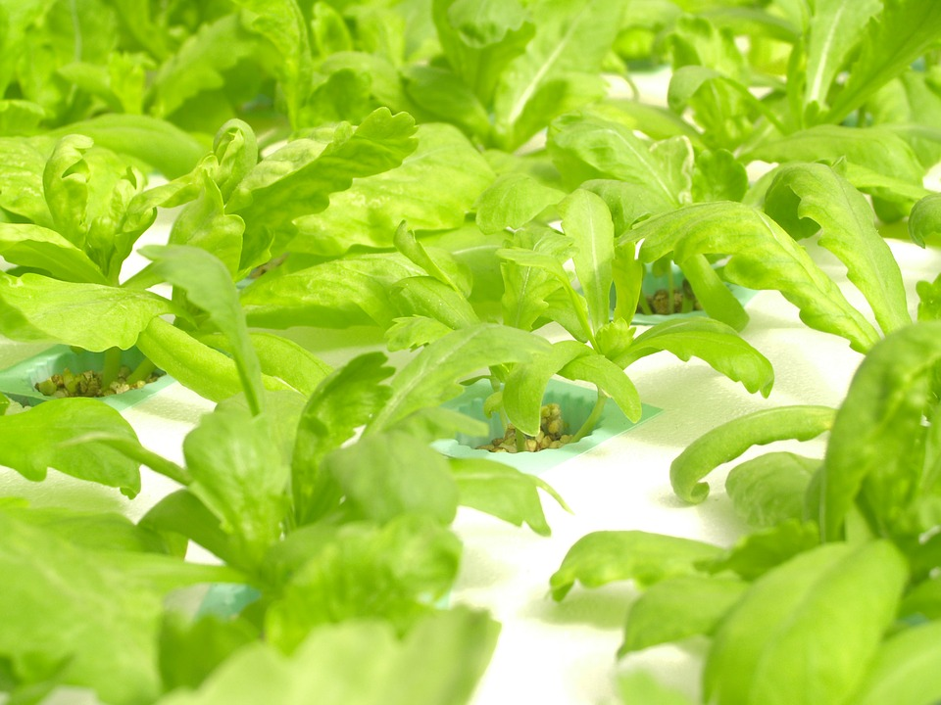

Using hydroponics is a method of growing plants without the use of soil, only oxygen, water, and nutrients. That means your vegetation can grow virtually anywhere, whether indoors or outside. Go to https://www.thespruce.com/beginners-guide-to-hydroponics-1939215/ for a guide on these units for beginners.

When implementing traditional planting methods with soil, a tremendous amount of water gets wasted by soaking more into the surrounding ground without absorption into the plant. Using this method takes as much as 90% less water for successful growth.

The water that does get used recirculates, meaning the only waste is via evaporation. Still, a few systems can collect even the evaporated substance and send it back through the unit. That makes it a unique and conservative measure for countries where water is scarce.

Hydroponics Systems

Hydroponics is a unique system of growing plants, but these don't offer merely a single process; there are up to 7 primary subsets plus variances of those. The standard forms used are:

- The Drip Method
- Wick System
- Ebb And Flow
- Nutrient Film
- Water Culture
- Aeroponics
- (NFT) Nutrient Film Technique

Soiled gardens depend on nature but require additional watering plus fertilizers. With hydroponics, there's a need for electricity that works to power the air pump for hydroponics or water pumps to keep the plant supplied with water, oxygen, and nutrients to encourage the healthiest growth.

If there is a disruption of the electrical component, it will undoubtedly impact the vegetation's overall health. That makes it essential to monitor the system closely so prompt responses occur.

Adding grow lights to the unit provides the necessary lighting so that growth can take place throughout the year instead of a specific season. It's a convenient, safe way to have fruits and vegetables any time you want them.

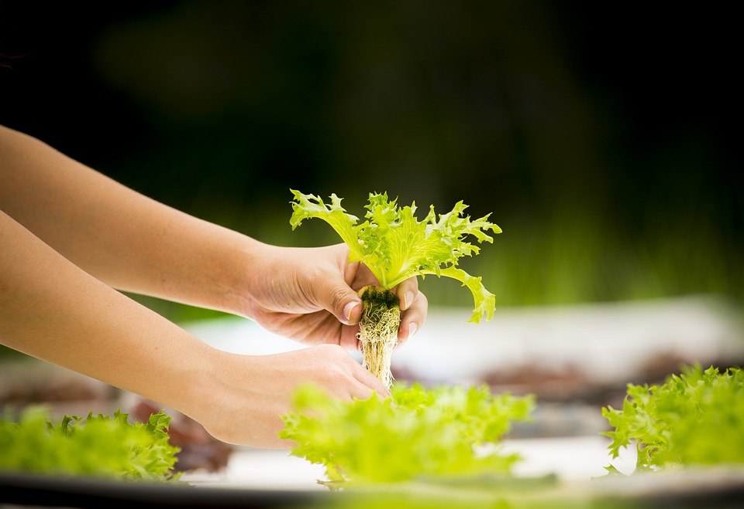

Facts You Might Not Know on Hydroponics

Hydroponics is a process that requires minimal effort compared to traditional gardening methods. With soiled strategies, roots maneuver down through the ground to look for their nutrients and search for water.

With the simplicity of the hydroponic process, all the plant's needs are provided without having to go searching for it and in ample quantities. It allows for as much as 50% faster-growing, allowing cultivating more crops than the traditional soil growth process. Some facts most people are unaware of include:

- Larger Plants: Fruits/vegetables have the potential for being almost double their standard size because of the efficiency of the conditions under which they are grown, plus they have less chance for disease, making the need for pesticides nil.

There is great concern over foods exposed to these weedkillers, fungicides, and pesticides, but it is much less common than with soiled-grown plants.

- Weeding: One of the most time-intensive and frustrating chores associated with gardening is weeding, but it's not necessary without the use of soil. There is a greater sense of control over the entire garden atmosphere by the gardener.

You determine the temperature, light, humidity along with the level of oxygen, water, and nutrients received by the vegetation. Depending on the type of garden you have will designate the approach you use.

A simple herb setup will not need a stringent regimen where you'll want to optimize perhaps a crop that might have use for commercial purposes.

- Pay Attention: It might be a simplistic option for the average gardener, but it's not a set-and-forget operation. A hydroponic system does require monitoring as any garden would but for different reasons.

You need to pay attention to the nutrient solution, the temperature, and other elements to make sure the plants thrive. A plant will become stressed and ultimately succumb if the atmosphere changes abruptly or ventures drastically from what has become comfortable for it.

The surrounding dirt would become like a buffer with soiled growth if the nutrient concentration or pH changed abruptly. Adjustments need to be taken care of frequently with hydroponics as the water absorbs into the plant along with the nutrients coming out of the solution, plus evaporation of water, creating continuous changes to the environment.

With these consistent changes in the atmosphere comes a requirement for continuous monitoring and corrections to maintain plant health.

- Budget-Friendly: The system can be as DIY or extravagant as you choose. Many people have the misperception that the hobby is not budget friendly. You can purchase everyday items for minimal cost to create a very simplistic deep-water culture unit. An even less complex setup is a basic wick version using empty soda bottles.

For someone who wants total sophistication, some systems go as high as $10,000, ready-made, in the "aquaculture" platform boasting as developing enough vegetation to satisfy a big family for the entire year.

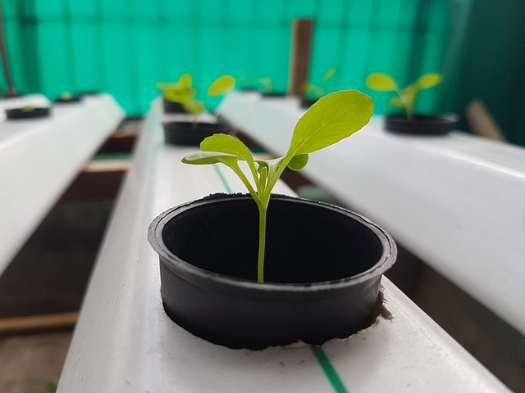

It is genuinely easy for anyone to develop a hydroponic garden for their household with countless guides and plans online to help you through the process. DIY is the most cost-effective way to go, but if you decide to go bigger or want something prebuilt, the price point will reflect that.

Hydroponics is an ideal choice for people who want a garden but might be short on space, perhaps in a small apartment or a more urban area where you might not enjoy a significant amount of room, or the soiled area is limited.

Plants grown in soil cannot be placed closely together, or they battle each other for resources, drastically reducing the size and decreasing what you yield from your planting.

Hydroponics takes up little space with plants growing side by side since their water, nutrients, and oxygen are in abundance and delivered directly individually. That means more substantial vegetation and greater quantities. Look here for a few expert tips and secrets they share.

Final Thought

A hydroponic system is a unique gardening option for people who might want to grow vegetation but don't necessarily have the most remarkable ability as a gardener - at least with the soiled methodology.

The process is controlled, making it simpler to grow healthy, abundant plants, so you cannot help but be successful no matter your skill level. Some of us who have difficulty with even our cactus would appreciate this opportunity.

